**Chapter 7**

**RESULTS**

**7.1 Snapshots**

**Figure 7.1 Snapshot of Home Page**

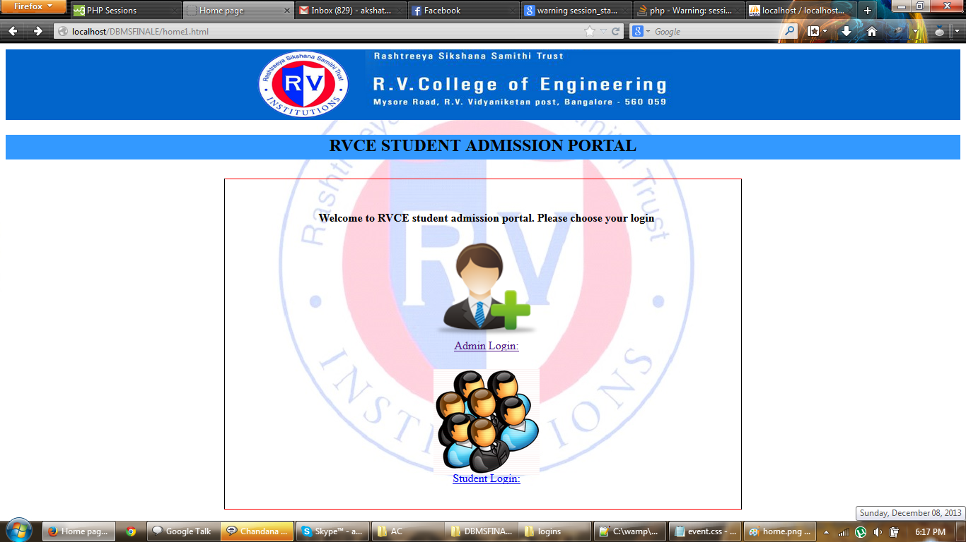

**Figure 7.2 Snapshot of Login Page (for admin)**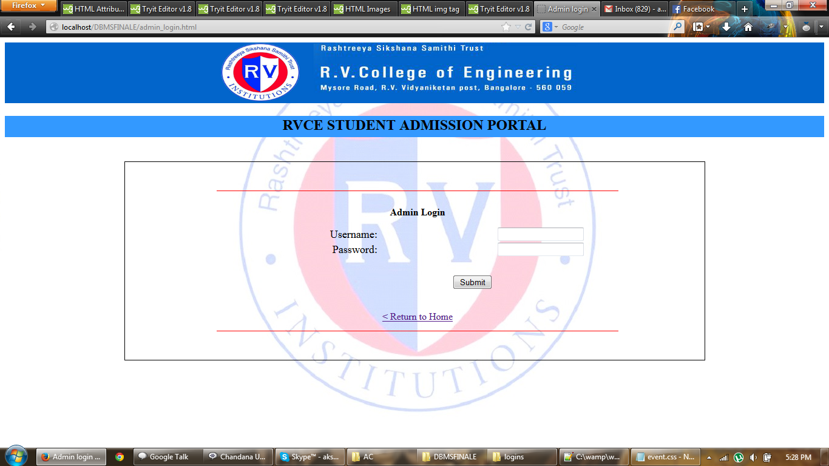

**Figure 7.3 Snapshot of candidate registration page**

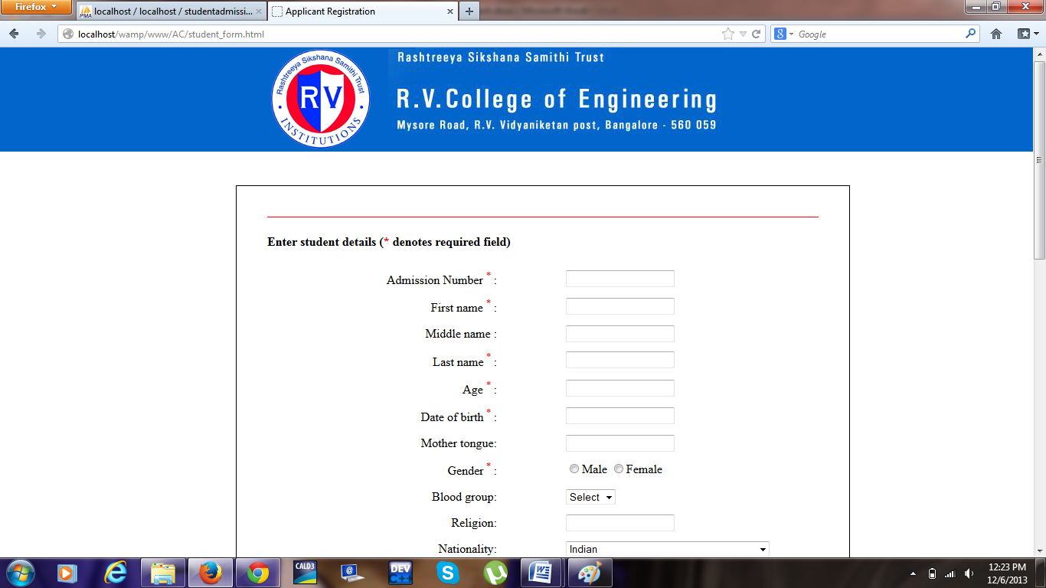

**Figure 7.4 Snapshot of successful student login**

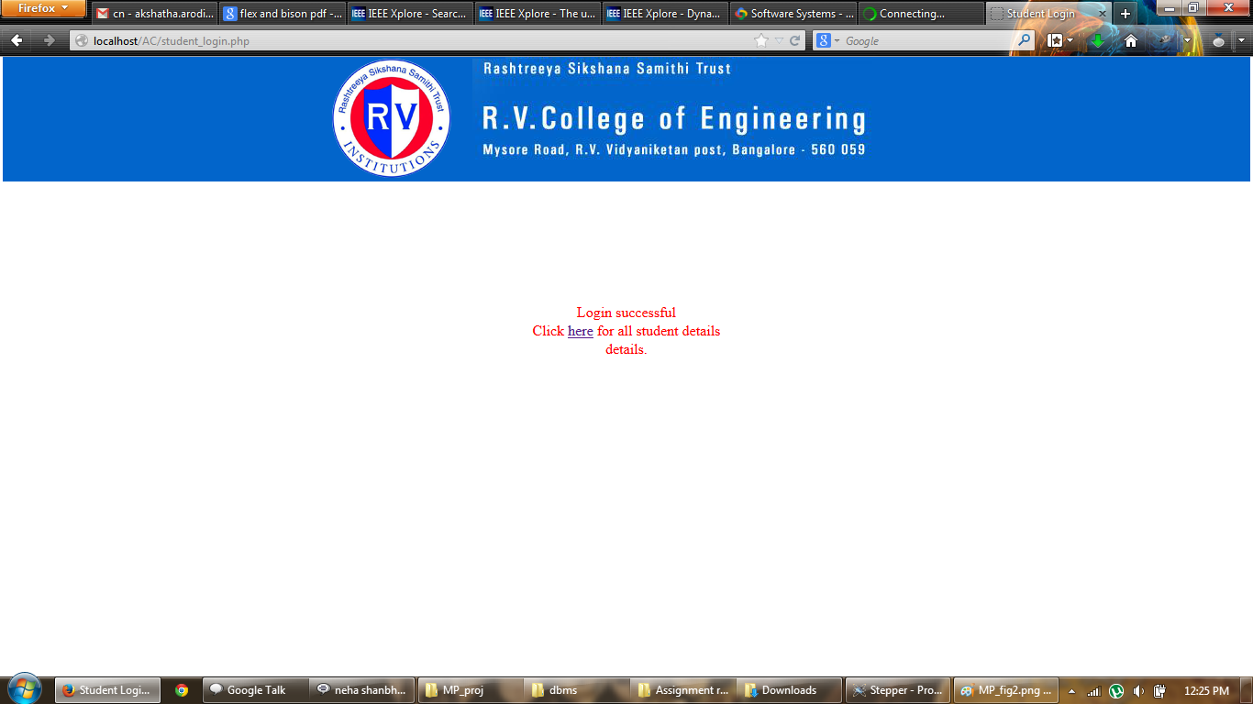

**Figure 7.5 Snapshot of retrieving the student details**

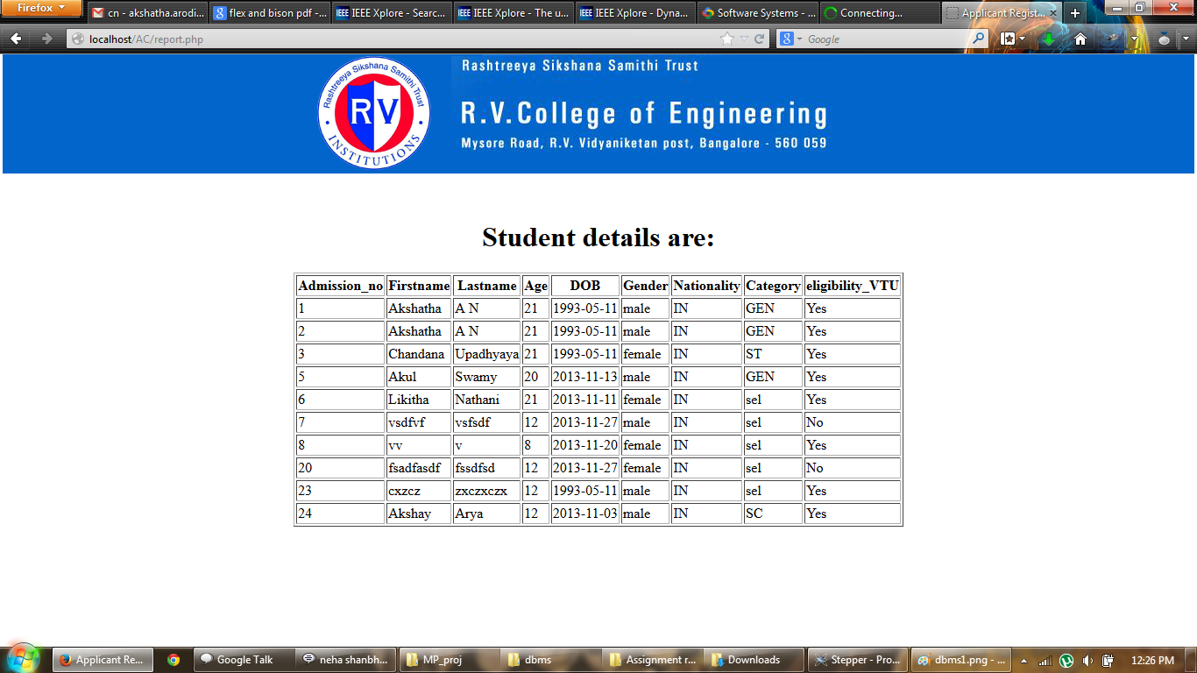

**Figure 7.6 Snapshot of drop down box for admission number with valid options only**

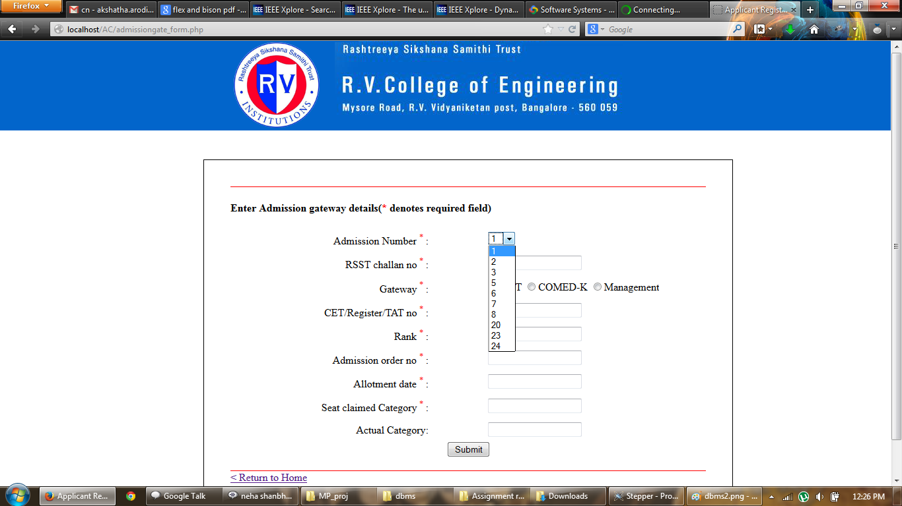

**Figure 7.7 Snapshot of error messages for invalid entry**

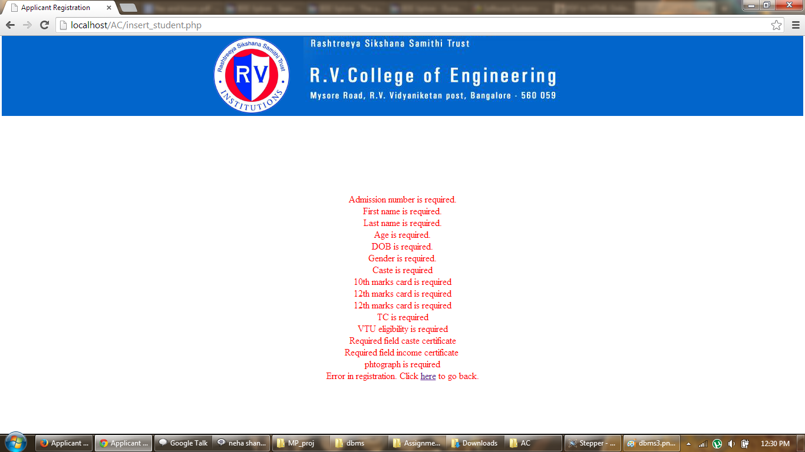

**Figure 7.8 Snapshot of calendar suggestion for dates**

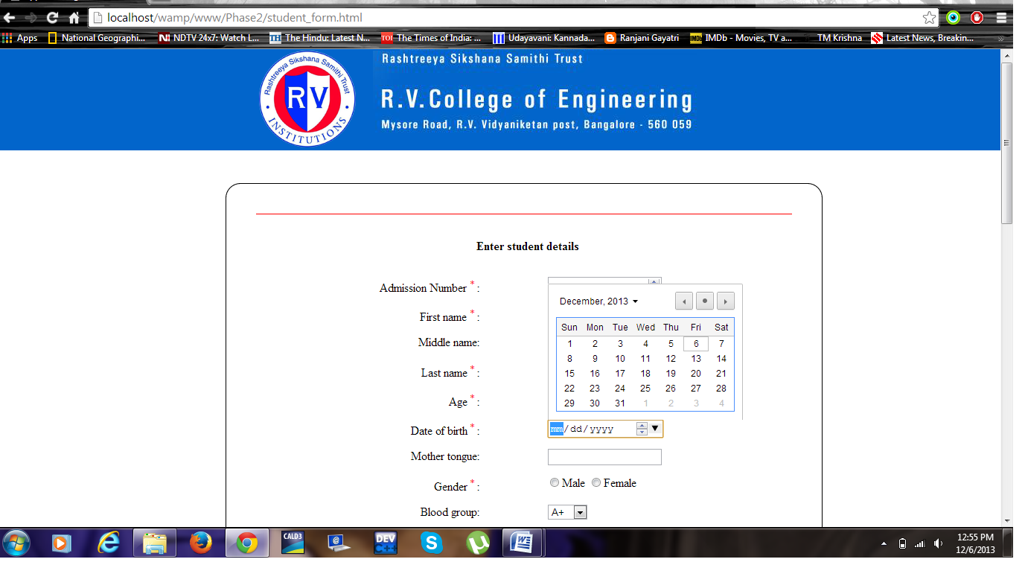

**7.2 Advantages of the project**

This project is built to provide the following advantages.

* The AR software keeps track of all students admitted to the college.
* AR module provides the facility of username and password for each student so that they can easily access or modify their info without taking help of administrator.
* The AR module unifies the usernames of students.
* The AR module provides the student to update only their contact details.
* Only admin can insert and update the details of the student.
* AR module also provides report generations.
* It allows the user to choose only those admission numbers which are valid. This is done using a drop down box.
* Sms alerts and emails are sent to the students who are successfully admitted to the college.

**7.3 Limitations of the project**

The project has its own limitations

* Applicant Registration does not provide the student himself/herself to do the registration.
* AR has the admission facility only for BTech/ Barch students and not for MTech students.
* Applicant Registration till now doesn’t have any auto security for spam or waste accounts, that are to be verified by administrator from time to time.